Principles of Communication

Systems Lab

Lab 4, 15th September 2019

Pratyush Nandi (IMT2017518)

Answer to Q1

Note: For question 1

m(t) = Σ​n=1​N ​b​c​[n]sin(pi*(t-n)),

where bc is an array of randomly generated symbols.

Sm(f) = Abs(FFT(m(t)))^2/length(bc),

Where Sm(f) is power spectral density.

Length of bc = 4, T = 1ms, frequency is in Hz.

m(t) is message signal and u(t) is DSB signal.

1.1)

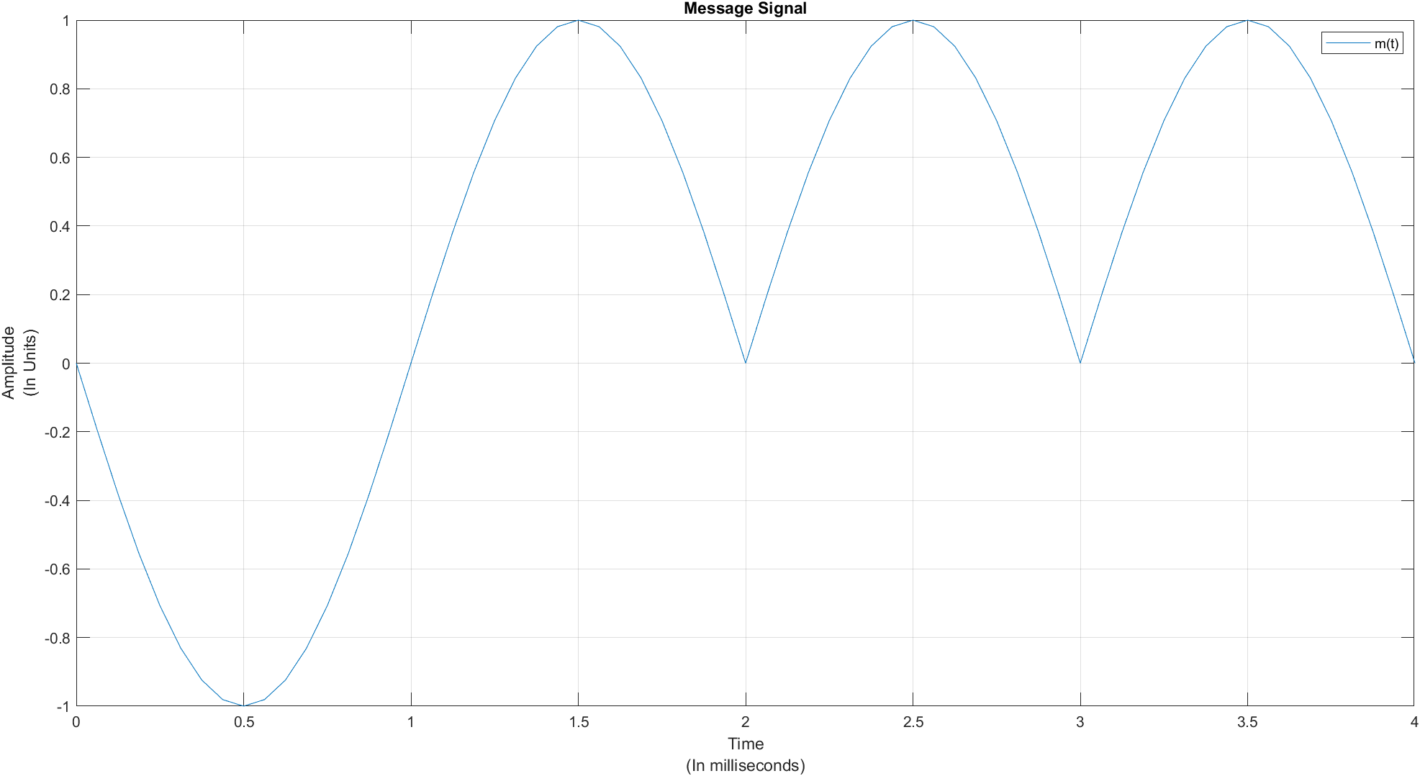

1.2)

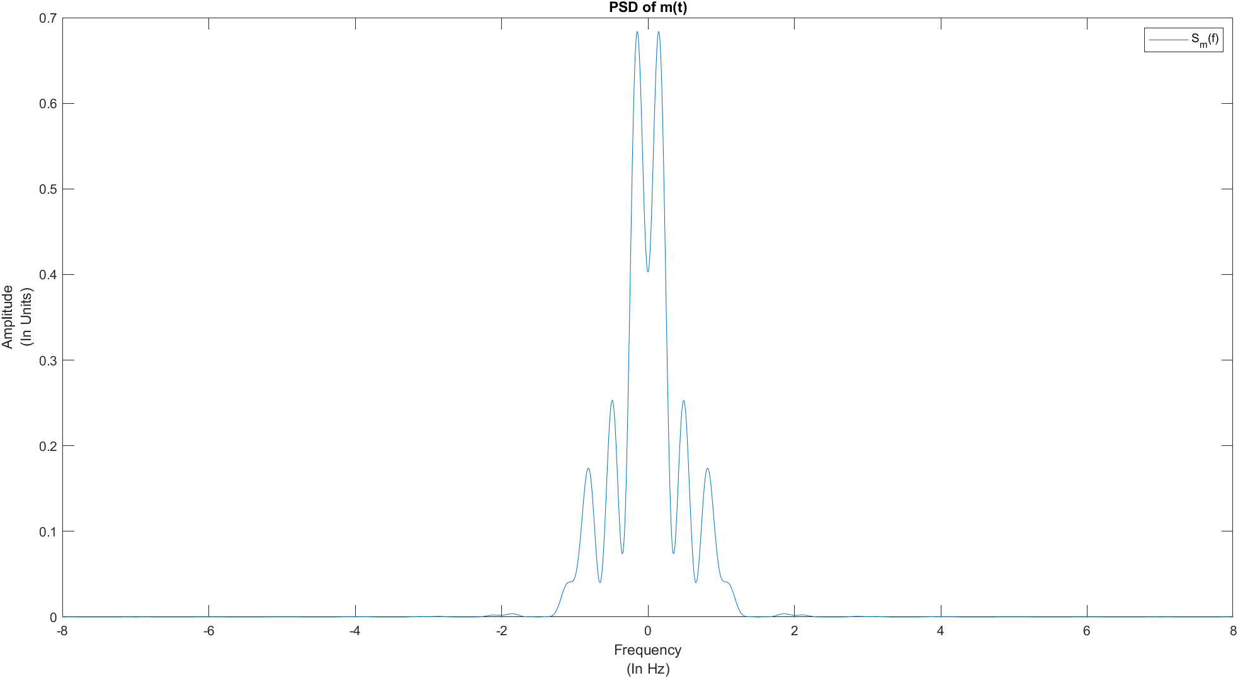

2)

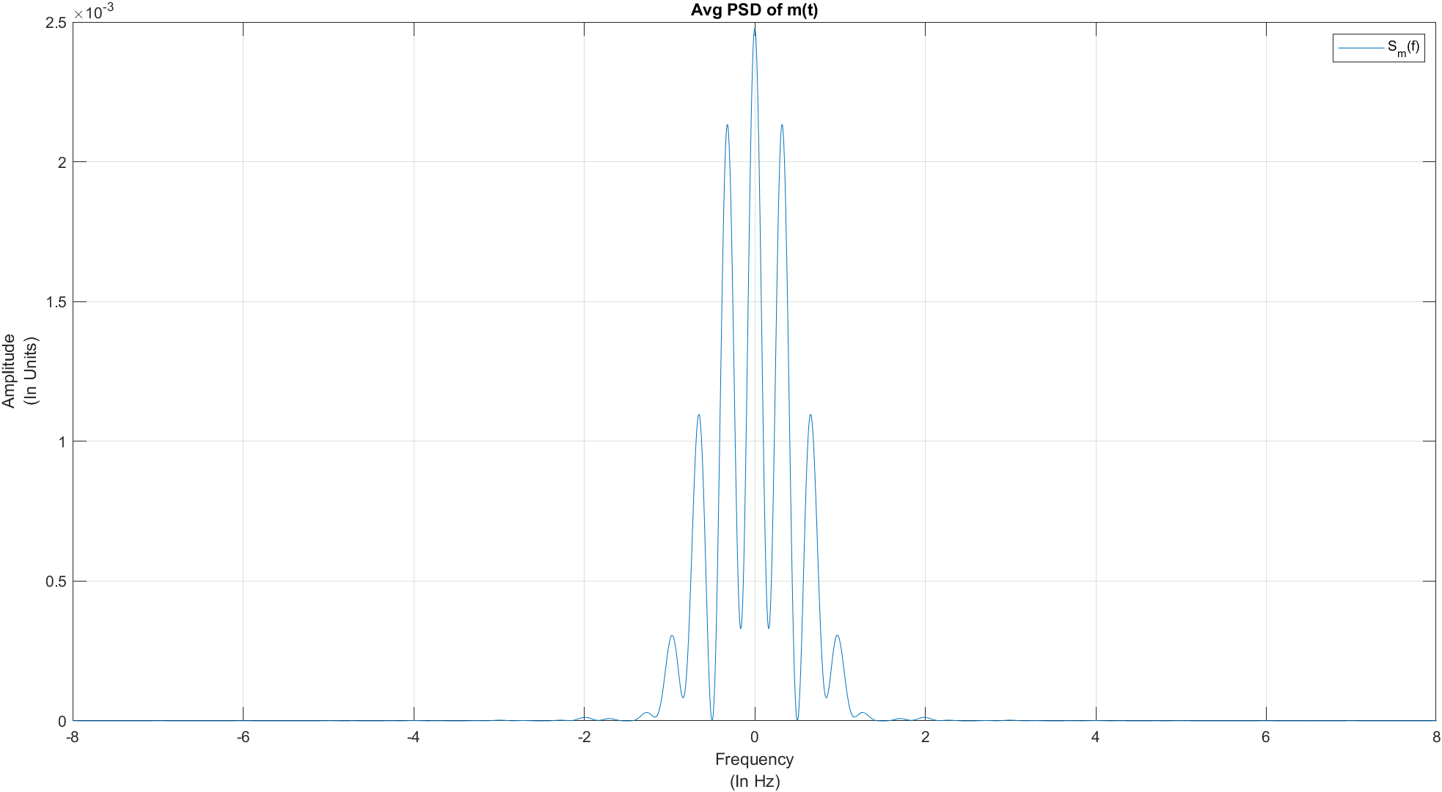

Ans: The bandwidth is around 3Hz.

3)

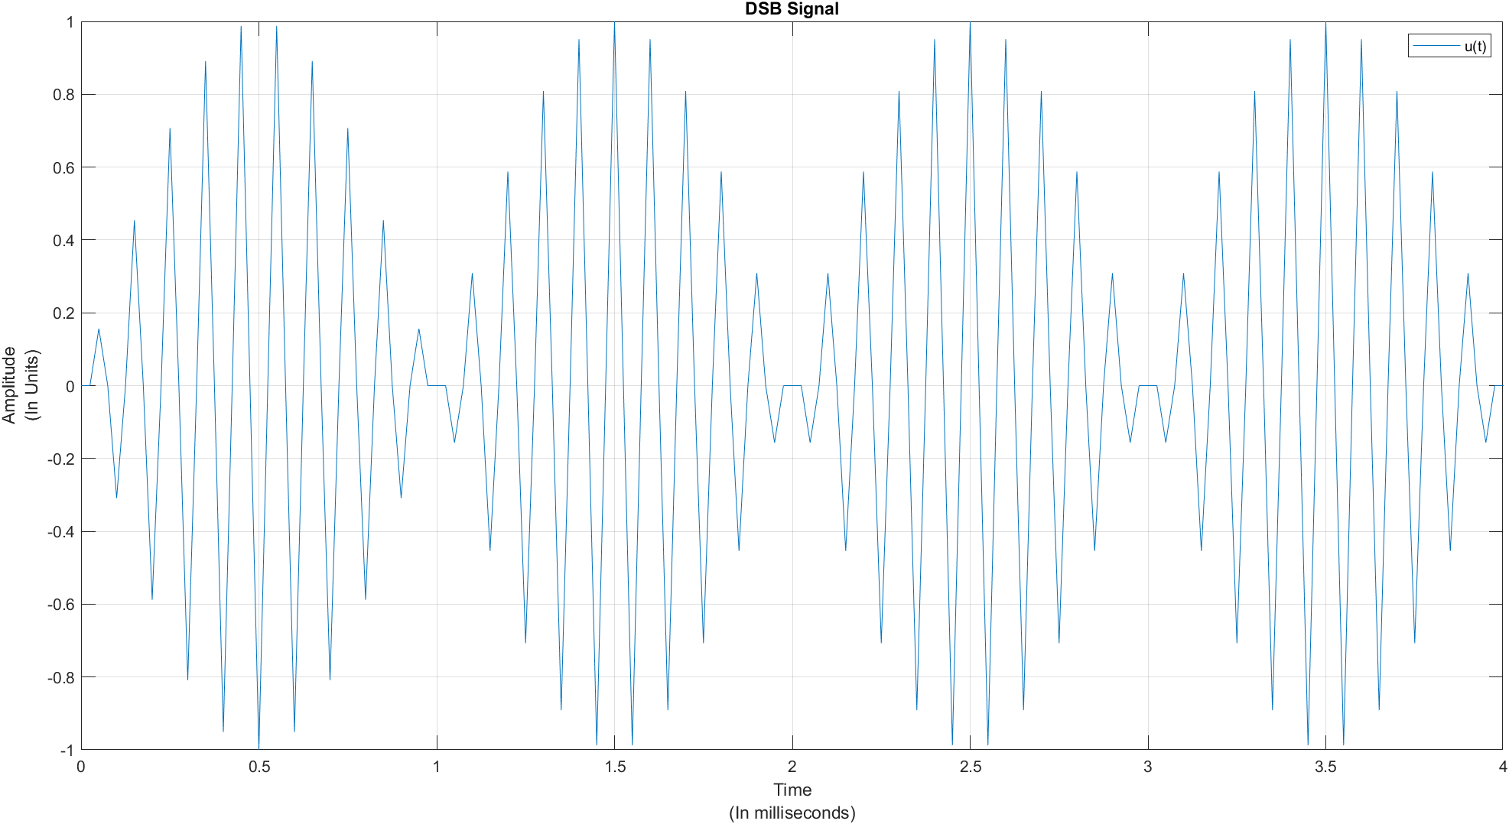

4)

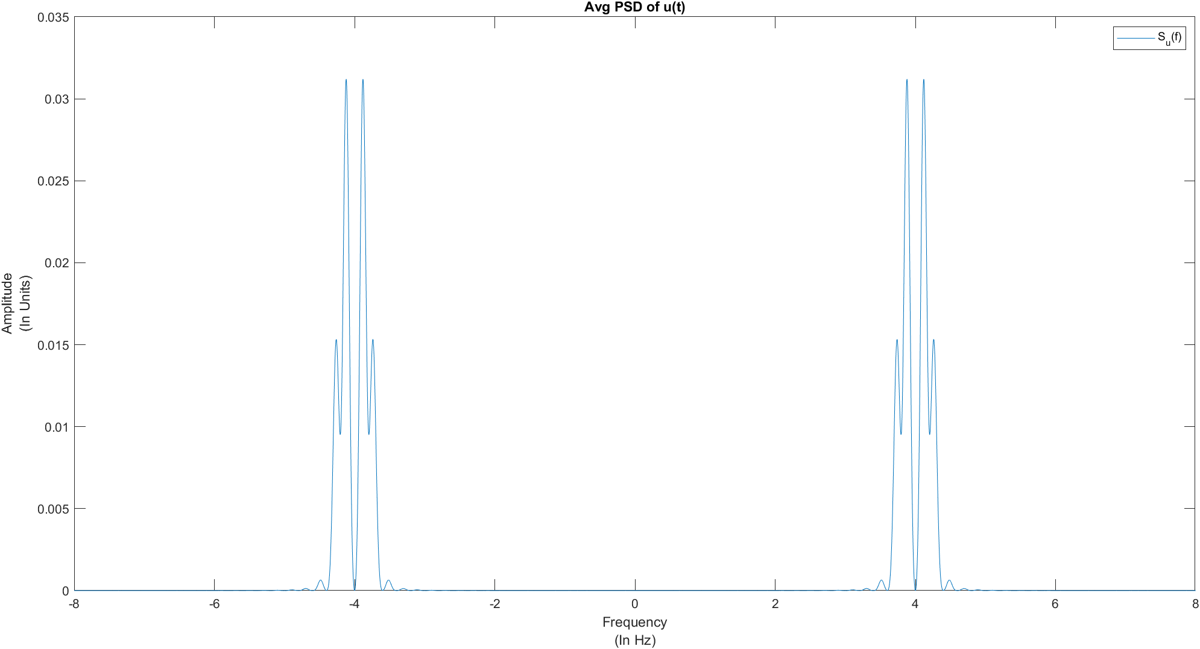

Ans: The values in this graph are around ¼ times the values in graph for question 1.2.

5.1)

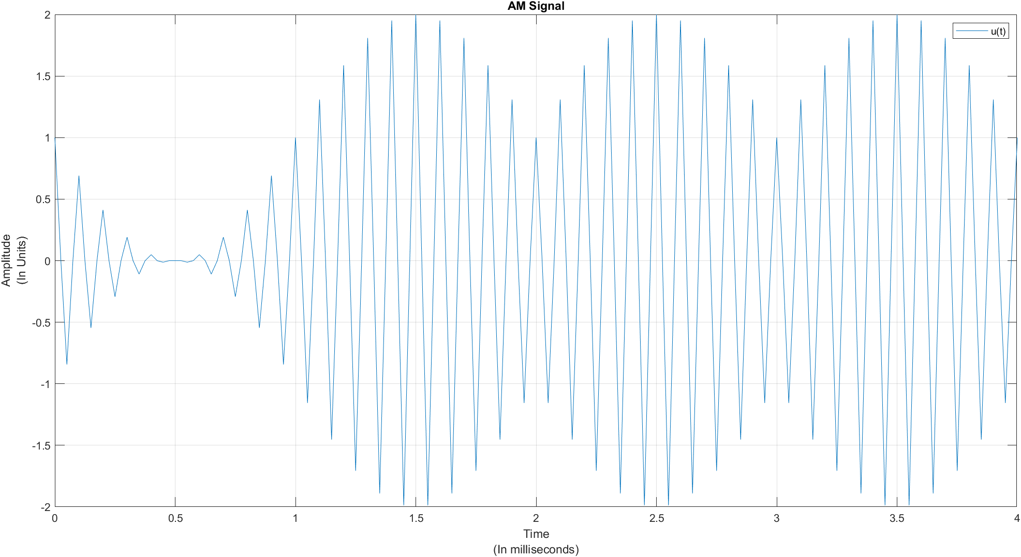

5.2)

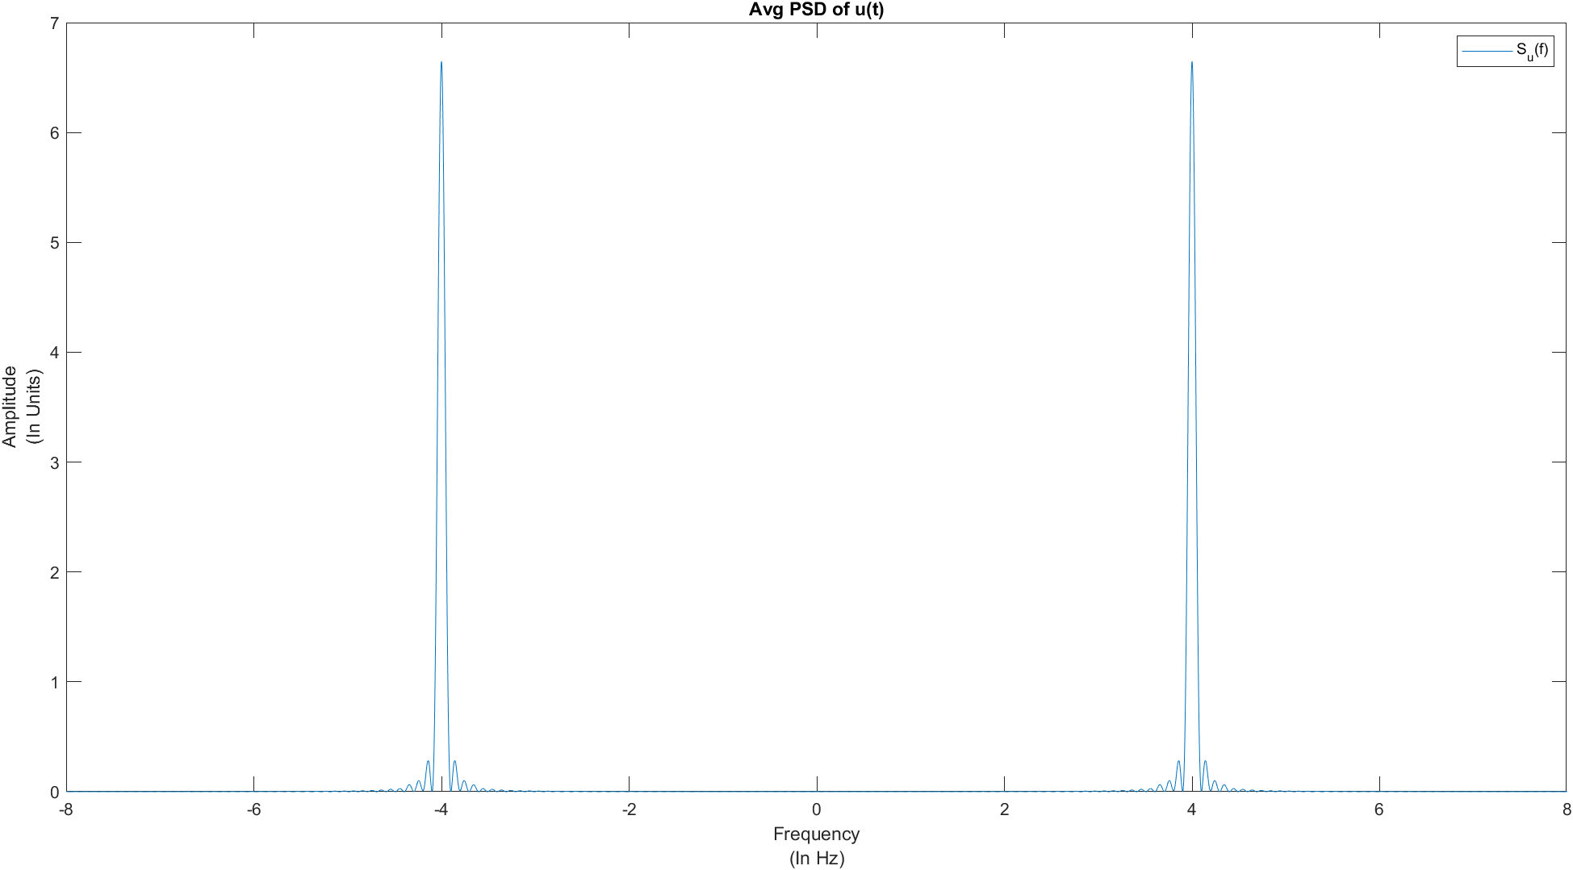

Ans: No difficulty was encountered while calculating PSD for 5.1 graph.

Note: For question 3 and 4 u(t) = m(t) cos 2πf​c​t, where fc = 10Khz and for question 5

u(t) = (A​c​ + m(t)) cos 2πf​c​t, where Ac = 1 and fc = 10Khz.

Appendix:

m = 16;

dt = 1/m;

t = -2:dt:2;

time_p = 0:1/m:1;

p = sin(pi*time_p);

A = [-1, 1];

symbols = 1:4;

for i = 1:4

pos = randi(2);

symbols(i) = A(pos);

end

bc = [-1;1;1;-1];

[uc,tc] = upsampler(p,symbols,m,4);

figure;

plot(tc,uc);

xlabel({'Time','(In milliseconds)'});ylabel({'Amplitude','(In Units)'});

title('Message Signal');

legend('m(t)');

grid on;

[Y,f] = FFT(uc);

figure;

plot(f,((abs(Y).*abs(Y))/4));

xlabel({'Frequency','(In Hz)'});ylabel({'Amplitude','(In Units)'});

title('PSD of m(t)');

legend('S_m(f)');

Y1 = Avg(p,dt,Y);

figure;

plot(f,((abs(Y1).*abs(Y1))/4));

xlabel({'Frequency','(In Hz)'});ylabel({'Amplitude','(In Units)'});

title('Avg PSD of m(t)');

legend('S_m(f)');

grid on;

fc = 10;

m1 = 4*fc;

time_p1 = 0:1/m1:1;

p1 = sin(pi*time_p1);

[uc1,tc1] = upsampler(p1,symbols,m1,4);

u = uc1 .* (cos(2 * pi * fc * tc1));

figure;

plot(tc1,u);

xlabel({'Time','(In milliseconds)'});ylabel({'Amplitude','(In Units)'});

title('DSB Signal');

legend('u(t)');

grid on;

[Y2,f2] = FFT(u);

Y3 = DSBAvg(p1,dt,Y2);

figure;

plot(f,((abs(Y3).*abs(Y3))/4));

xlabel({'Frequency','(In Hz)'});ylabel({'Amplitude','(In Units)'});

title('Avg PSD of u(t)');

legend('S_u(f)');

Ac = 1;

u1 = (Ac+uc1).*(cos(2 * pi * fc * tc1));

figure;

plot(tc1,u1);

xlabel({'Time','(In milliseconds)'});ylabel({'Amplitude','(In Units)'});

title('AM Signal');

legend('u(t)');

grid on;

[Y4,f4] = FFT(u1);

Y5 = AMAvg(p1,dt,Y4);

figure;

plot(f,((abs(Y5).*abs(Y5))/4));

xlabel({'Frequency','(In Hz)'});ylabel({'Amplitude','(In Units)'});

title('Avg PSD of u(t)');

legend('S_u(f)');

function Y2 = Avg(p,dt,Y)

m= 16;

for i = 1:50

A = [-1, 1];

symbols = 1:4;

for j = 1:4

pos = randi(2);

symbols(j) = A(pos);

end

[uc,tc] = upsampler(p,symbols,m,4);

[Y1,f1] = FFT(uc);

Y = ((Y*i)+Y1)/(i+1);

end

Y2 = Y;

end

function Y2 = DSBAvg(p,dt,Y)

fc = 10;

m= 4*fc;

symbols1 = 1:50;

for i = 1:50

A = [-1, 1];

symbols = 1:4;

for j = 1:4

pos = randi(2);

symbols(j) = A(pos);

end

[uc,tc] = upsampler(p,symbols,m,4);

u = uc .* (cos(2 * pi * fc * tc));

[Y1,f1] = FFT(u);

Y = ((Y*i)+Y1)/(i+1);

end

Y2 = Y;

end

function Y2 = AMAvg(p,dt,Y)

fc = 10;

m= 4*fc;

Ac = 1;

for i = 1:50

A = [-1, 1];

symbols = 1:4;

for j = 1:4

pos = randi(2);

symbols(j) = A(pos);

end

[uc,tc] = upsampler(p,symbols,m,4);

u1 = (Ac+uc).*(cos(2 * pi * fc * tc));

[Y1,f1] = FFT(u1);

Y = ((Y*i)+Y1)/(i+1);

end

Y2 = Y;

end

function [s,t] = upsampler(p,bc,m,N)

nsymbols = length(bc);

nsymbols_upsampled = 1 + (nsymbols - 1) * m;

symbols_upsampled = zeros(nsymbols_upsampled, 1);

symbols_upsampled(1:m:nsymbols_upsampled) = bc;

s = conv(symbols_upsampled,p);

t = 0:1/m:(length(s) - 1)/m;

s = s.';

end

function [signal_freqdomain_centered,freqs] = FFT(u)

ts = 1/16;

fs_desired = 1/1000;

Nmin = ceil(1/(fs_desired*ts));

Nfft = 2^(nextpow2(Nmin)) ;

signal_freqdomain = ts*fft(u,Nfft);

signal_freqdomain_centered = fftshift(signal_freqdomain);

fs=1/(Nfft*ts);

freqs = ((1:Nfft)-1-Nfft/2)*fs;

end